Template for EXTENDED ABSTRACT Publication in the Proceedings of IAMaC 2023

**Full Name of the First Author** a**, Full Name of the Second Author**b**, Full Name of the Third Author**c

aFirst author affiliation

Address, City and Postcode, Country

e-mail address

bSecond author affiliation (if institution b is different than a or c)

Address, City and Postcode, Country

e-mail address

cThird author affiliation (if institution c is different than a or b)

Address, City and Postcode, Country

e-mail

**Keywords:** keyword 1, keyword 2 … (up to 5 keywords)

# IntroduCTION

The proceedings of the IAMaC will be published in Adobe™ PDF format. The manuscript must be formatted strictly according to these instructions.

The present file can be used as a template for Microsoft Word™ users; try and use the provided styles for Title, Headings, Section Body, Equations, Captions, etc.

This document should be used as a formatting guide to users of other text processing software.

As basic hints keep as much as possible the format presented here.

Avoid the use of empty lines.

There are styles dedicated to Tables, Figures and Equations, which will be explained in more detail in the next sections.

The extended abstracts are limited to a maximum of 4 (four) pages and a minimum of 1 (one) page, including tables and figures. The final PDF file must not exceed 5.0 Mb.

# Text format

The manuscripts should be written in Portuguese, Spanish or English, typed in A4 size pages, using font Times New Roman, size 11, except for the title, author’s affiliation and keywords, for which the format instructions are indicated above. Single space between lines is to be used throughout the manuscript.

All the pages must have a top margin of 3.5 cm, bottom margin of 3.0 cm and all the other margins (left and right) must have 2.5 cm.

The body of the text must be justified. The first line of each paragraph must be indented by 1.25 cm. All information must be provided directly in the text, or by reference to widely available published work. Footnotes should be avoided.

All symbols and notation must be defined in the text. Physical quantities must be expressed in the SI (metric) units.

In order to avoid units braking in the next line use *Ctrl+Shift+space* between the numerical value and the unit. Mathematical symbols appearing in the text must be typed in *italic* style.

## Section and subtitles

The section headers and sub headers must be aligned at left, typed with Times New Roman, size 11, bold style font, with the first letter capitalized and numbered consecutively. They must be numbered using Arabic numerals separated by points. The current MS Word template provides automatic numbering. No more than 3 sublevels should be used. One single line size 11 pt. must be included above each section title/subtitle (use the Section Body style).

## Construction of references

References should be listed at the end of the manuscript. Do not begin them on a new page unless this is absolutely necessary. Authors should ensure that every reference in the text appears in the list of references and vice versa. Indicate references by [1] or [2,3] in the text.

Some examples of how your references should be listed are given at the end of this template in the ‘References’ section, which will allow you to assemble your reference list according to the correct format and font size.

## Mathematical equations

The mathematical equations must be indented by 1.25 cm from the left margin. They must be typed using Times New Roman, size 11 pt. font. Arabic numerals must be used as equation numbers, enclosed between parentheses, right-aligned, as shown in the examples below. Equations should be referred to either as “Eq. (1)” in the middle of a phrase or as “Equation (1)” in the beginning of a sentence. Matrix and vector quantities can be indicated either by brackets and braces, as in Eq. (1), or in bold style, as in Eq. (2). Symbols used in the equations must be defined immediately before or after their first appearance. One blank line must be included above and below each equation.

 (1)

 (2)

## Tables

Tables should be placed in the text as close as possible to the text where they are first mentioned and must be numbered consecutively in Arabic numerals. All tables should have a caption placed above the table (use the same style as in this template). Only horizontal lines should be used within a table, to distinguish the column headings from the body of the table, and immediately above and below the table. Tables must be embedded into the text and not supplied separately.

Table 1 – An example of a table.

|  |  |  |
| --- | --- | --- |
| **An example of a column heading** | **Column A (*t*)** | **Column B (*t*)** |
| And an entry | 1 | 2 |
| And another entry | 3 | 4 |
| And another entry | 5 | 6 |

Tables must be referred to either as “Tab. 1” in the middle of a phrase or as “Table 1” in the beginning of a sentence. The tables themselves as well as their titles must be centered. The titles of the tables should not be longer than 3 lines, centered and use Times New Roman size 10 pt. The font style and size used in the tables must be similar (both in size and style) to those used in the text body, font size 10 pt. Units must be expressed in the S.I. (metric) system. Explanations, if any, should be given at the foot of the tables, not within the tables themselves.

One blank line must be left before and after each table. Below, there is an example, Tab. 1.

## Figures

Figures should be placed in the manuscript as close as possible to the text where they are first mentioned and must be numbered consecutively in Arabic numerals. All figures should have a caption placed below the figure (use the same style as in this template).

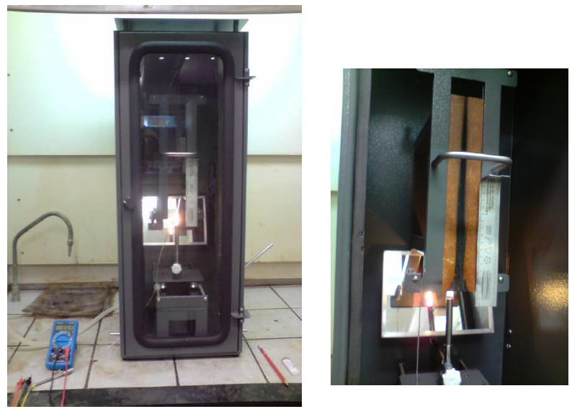

(a) (b)

Figure 1 – An example of figure (a) first picture; (b) second picture.

Figures must be referred to either as “Fig. 1” in the middle of a phrase or as “Figure 1” in the beginning of a sentence. The figures themselves as well as their captions must be centered. The captions of the figures should not be longer than 3 lines, centered and use Times New Roman size 10 pt.

The caption for the data symbols as well as the labels for each curve should be included into the figure. Lettering should be large enough for ease reading. All units must be expressed in the S.I. (metric) system. One blank line must be left before and after each figure.

Color figures and photographs with good resolution can be included in the manuscript. To reduce the file size and preserve the graphic resolution, figures must be saved into GIF (figures with less than 16 colors) or JPEG (for higher color density) files before being inserted in the manuscript.

acknowledgements

This optional section must be placed before the list of references.

REFERences

The list of references must be introduced as a new section, located at the end of the manuscript. The first line of each reference must be aligned at left. All the other lines must be indented by 1.25 cm from the left margin. All references included in the reference list must have been mentioned in the text.

1. M. Sartorato. *Micro and macroscale analyses for prognosis of composite structures: A new physics based multiscale methodology*. PhD Thesis. University of Sao Paulo. (2018).
2. T.H.G Megson. *Aircraft structures – for engineering students*. John Wiley & Sons Inc. New York. 2nd edition. (1990).
3. J.H. Troitzsch. Overview of flame retardants. *Chemistry Today*, v.16, January/February. (1998).
4. R.M. Rowell. *A new generation of composite materials from agro-based fiber*. In:Prasad, P. N.; Mark, James E.; Fai, Ting Joo, eds. Polymers and other advanced materials: emerging technologies and business opportunities. Proceedings of the 3rd International conference on frontiers of polymers and advanced materials; January 16-20; Kuata Lumpur, Malaysia. New York, NY: Plenum Press: 659-665. (1995).
5. FAR (Federal Aviation Regulation) *Part 25: Airworthiness standards: Transport category airplanes. Aviation Supplies and Academics*. (2008).
6. American Society for Testing and Materials – D638-03. *Standard test method for tensile properties of plastics*. EUA: 15p. (2003).
7. American Society for Testing and Materials – D790-03. *Standard test methods for flexural properties of unreinforced and reinforced plastics and electrical insulating materials*. EUA: 11p. (2003).
8. V. Tita. *Composite structures design and analysis*. In: Dynamics of Smart Systems and Structures.1st edition: Springer International Publishing, p. 217-263. (2016).
9. FAA (Federal Aviation Administration). *Aircraft Materials Fire Test Handbook*. National Technical Information Service (NTIS), Springfield, Virginia. (2000).
10. J. Jang, H. Chung, M. Kim et al. The effect of flame retardants on the flammability and mechanical properties of paper-sludge/phenolic composite. *Polymer Testing*, v. 19, p. 269–279. (2000).
11. V. Tita, J. de Carvalho, D. Vandepitte. Failure analysis of low velocity impact on thin composite laminates: Experimental and numerical approaches. *Composite Structures*, v.83, p. 413–428. (2008).
12. Y. Kiuchi, M. Iji, H. Nagashima, et al. Increase in flame retardance of glass-epoxy laminates without halogen or phosphorous compounds by simultaneous use of incombustible-gas generator and charring promoter. *Journal of Applied Polymer Science*, v. 101, p. 3367–3375. (2006).
13. V.L.P. Salazar, J.C. Caraschi, A.L. Leão. Avaliação dos produtos de emissão a partir da pirólise de assentos automotivos feitos de fibra de coco e de espuma de poliuretano. *Engenharia Sanitária e Ambiental*, v.10, p.162-166. (2005).
14. I. Sobolev and E.A. Woycheshin, *Alumina Trihydrate*. In: Handbook of fillers for plastics. 1ed. New York, USA: Van Nostrand Reinhold. (1987).

RESPONSIBILITY NOTICE

The author(s) is (are) the only responsible for the printed material included in this manuscript.